Capstone Project Report: IndustryGPT for Retail and E-Commerce
By - Ali Hamza Habib

➣ This report documents the current QLoRA-based version of the project. It includes the data preparation process, exploratory analysis, model fine-tuning, and bot testing plan.
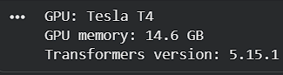

1. Industry Selection
I selected Retail and E-Commerce because many customer questions follow recurring patterns but still need a clear, context-aware reply. Customers ask about carts, returns, delivery, payment, and account changes, and a generic chatbot can easily give vague answers. The aim of this project is to adapt a conversational model so that it recognises these retail-specific situations and gives useful general guidance.The bot is designed as a support assistant, not as a replacement for a retailer's internal systems. It can explain common steps, but it cannot check a real order, access payment information, or make decisions about an individual customer's refund.

2. Data Collection, Cleaning, and Exploratory Data Analysis
The main source used in this project is the Bitext Retail and E-Commerce LLM Chatbot Training Dataset on Hugging Face. It contains customer instructions, support responses, categories, and intents. This source is relevant because it covers the kinds of conversations an e-commerce support bot is expected to handle. Only this public dataset is used in the notebook; no private customer logs or personal records are collected.Before training, I normalised spacing, removed empty examples, replaced generic template placeholders, filtered obvious duplicate question-answer pairs, and checked for simple personal-data patterns. I did not use stemming because it would make text less natural for a generative chatbot. Instead, the model's tokenizer converts the cleaned conversations into subword tokens. The resulting records are shuffled before a smaller training subset is selected for the T4 GPU run.
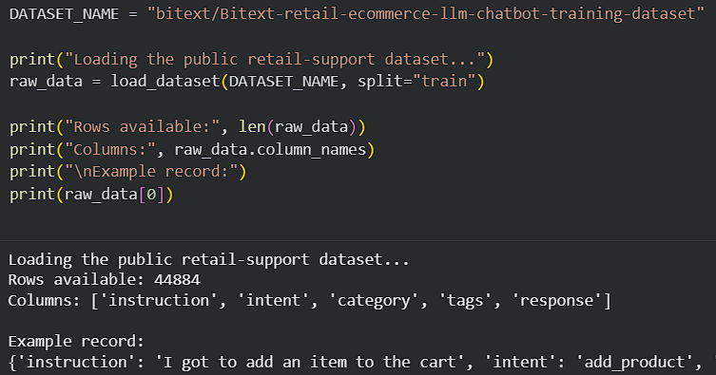

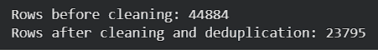
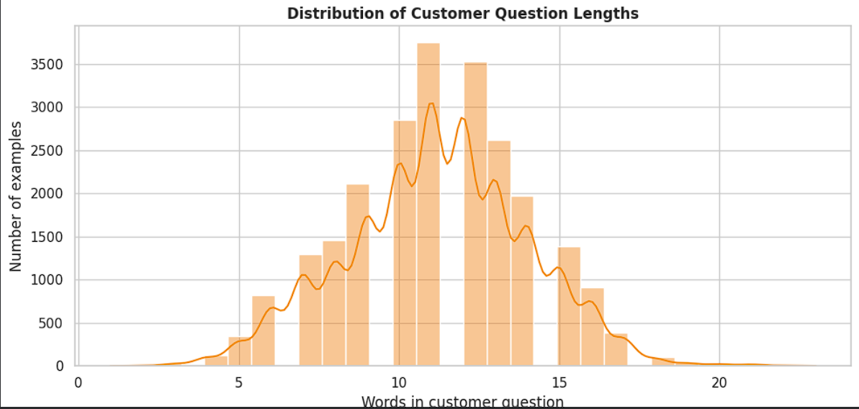
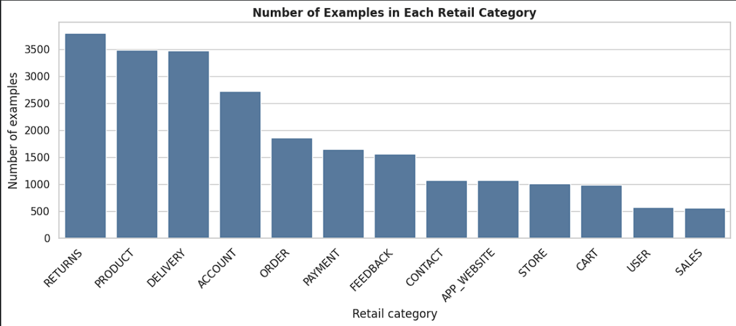
I also carried out exploratory data analysis before fine-tuning. The EDA checks the distribution of retail categories and support intents, along with the length of customer questions and support replies. These checks help identify uneven topic coverage and help choose a practical maximum token length.

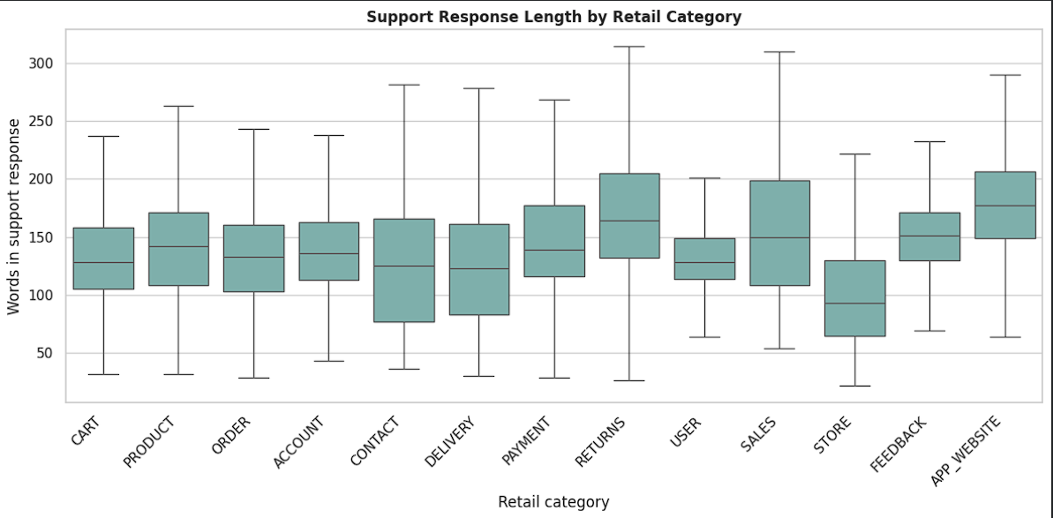
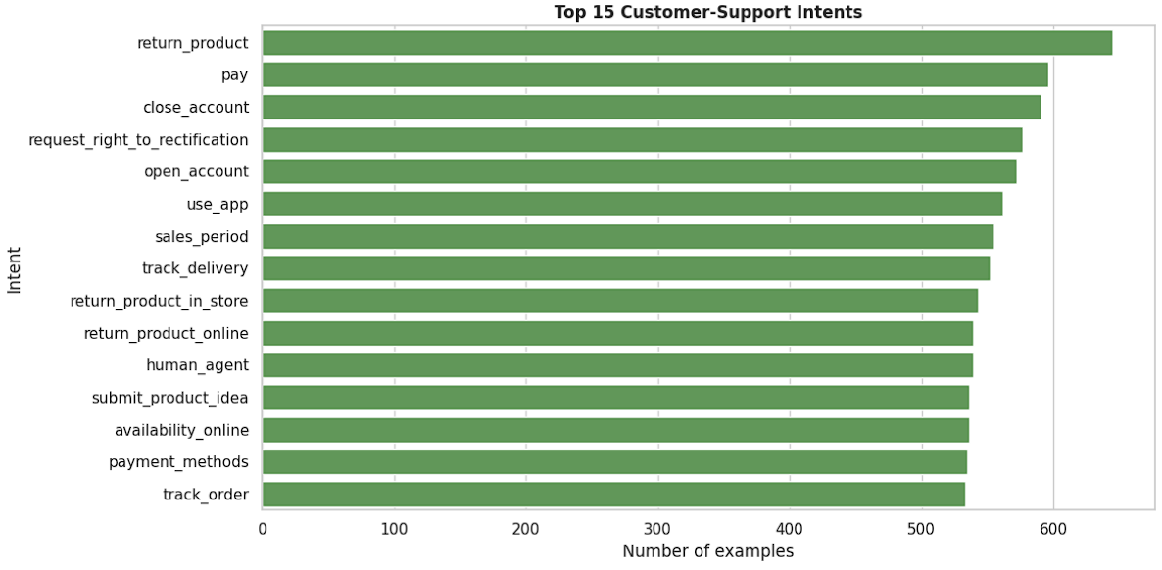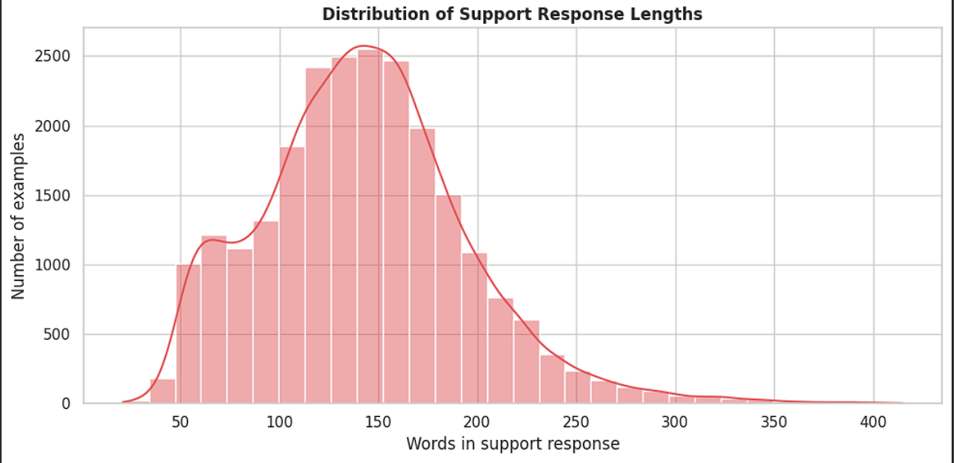

3. Model Selection and Training
I used TinyLlama-1.1B-Chat as the base model because it is small enough to run in Google Colab while already being designed for conversational text. The model is loaded with 4-bit quantisation and adapted with LoRA layers. This QLoRA setup keeps memory use manageable on a T4 GPU because only a small set of adapter parameters is trained instead of the whole model.
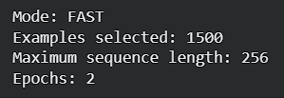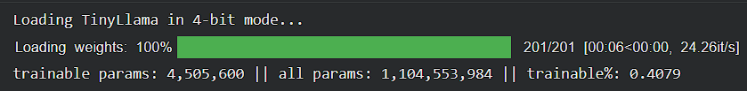
The notebook includes two settings. Fast mode uses 1,500 shuffled examples, a sequence length of 256, and two epochs so that the complete workflow can be tested quickly. The final setting uses 3,000 examples, a sequence length of 384, and three epochs. Both settings are comfortably below the project limit of 25 epochs. A validation split is retained so that the final model can be evaluated on records not used for parameter updates.
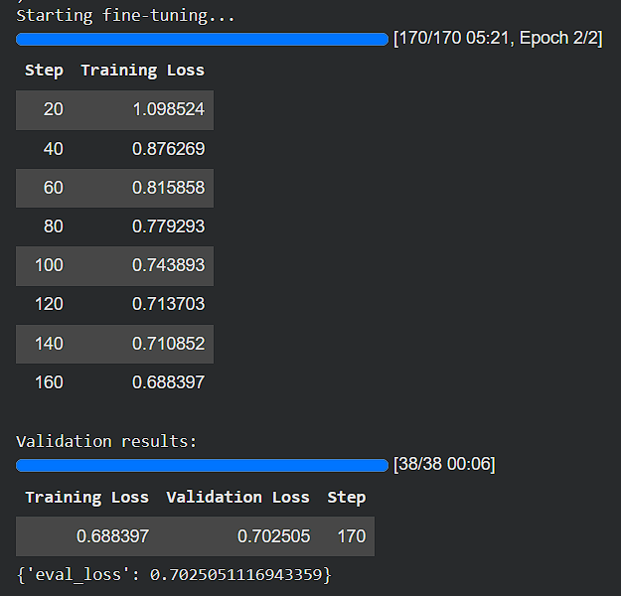

4. Bot Development and Testing
The final bot accepts a customer question, applies TinyLlama's chat template, and generates only the new assistant response. Using the same chat format in training and inference is important: it avoids the prompt mismatch that can cause a fine-tuned model to return incomplete or irrelevant answers. The generation settings use controlled sampling and a repetition penalty to keep answers readable.
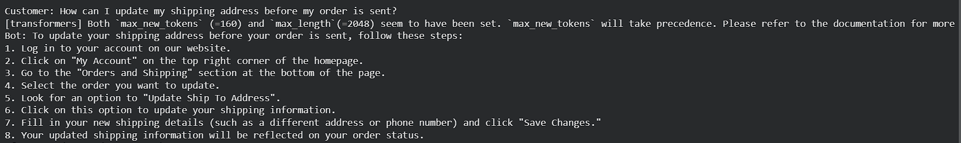
Testing should cover several retail scenarios, including cart support, returns, shipping-address changes, delivery delays, and payment methods. For each test, I will review whether the answer is relevant, polite, coherent, and honest about the bot's limitations.

5. Limitations
- Compact Model Scale: Built on a 1.1 billion parameter architecture (TinyLlama-1.1B-Chat), which provides high efficiency for local T4 GPU training but limits deep multi-step reasoning capabilities compared to larger 7B+ models.
- Lack of Real-Time Backend Integration: Operates purely as a standalone generative model without live API hooks or database connectivity to check real-time order tracking, live inventory levels, or user account data.
- Sequence Length Constraints: Training inputs are capped at a maximum length of 256 tokens, which restricts the model's ability to process extremely long, highly elaborate, or deeply nested customer support descriptions in a single pass.
- Domain Specificity Boundaries: Fine-tuned exclusively on a retail and e-commerce support dataset, limiting its generalization to other complex or regulated industries (such as finance, healthcare, or legal) without retraining.
- Stateless Multi-Turn Execution: The current inference setup evaluates prompts on a single instruction-response basis, lacking advanced conversational memory management or stateful tracking for long-running customer service tickets.

Project Summary
This project develops an industry-specific support bot for the retail and e-commerce sector. A public retail-support dataset is cleaned, explored through EDA, and converted into a chat format for TinyLlama-1.1B-Chat. QLoRA makes fine-tuning practical on a Google Colab T4 GPU, while a held-out validation split and practical customer questions provide a basic evaluation method. The project demonstrates domain adaptation, but a production bot would still need approved company policies, a current knowledge base, safety checks, and a route to human support for sensitive cases.

Sources
The Training Dataset: Bitext Retail and E-Commerce LLM Chatbot Training Dataset
The Base Model: TinyLlama-1.1B-Chat-v1.0 Model Card
Hugging Face PEFT Library: Hugging Face PEFT Documentation
BitsAndBytes (4-bit Quantization): BitsAndBytes GitHub Repository

